Welcome
In this edition of our ISFG newsletter, we provide information about the recent ISFG Congress in Prague, on new short-term fellowships for collaborative research & travel, about new publications as well as about the ISFG Congresses in 2021 and 2023.

28th ISFG Congress 2019 in Prague
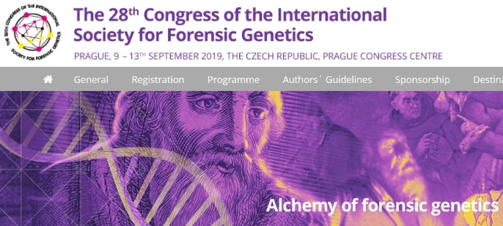
The 28th Congress of the International Society for Forensic Genetics (ISFG) in Prague, the capital of the Czech Republic, was very successful. It was the first ISFG Congress held in the Czech Republic, and with 1018 participants experienced a record number of attendees. The Congress was planned and organized by the ISFG Board in cooperation with the Local Organizing Committee (Andrea Cignová, Jiří Drábek, Veronika Gazdová, Marie Korabečná, Jana Matoušková, Martina Novotná, Tomáš Pexa, Halina Šimková, Petra Škapová, Kateřina Štaffová, Zuzana Štaffová, and Pavel Tomek), and the excellent professional conference planners (Karolína Tylšová, Soňa Horáčková, and their team from C-IN).
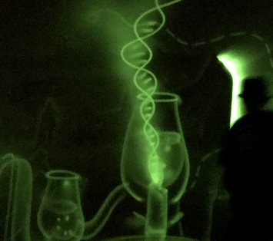
There were 14 pre-congress workshops involving 474 participants covering the following topics:
- Kinship Statistics using Familias and FamLink (Thore Egeland & Daniel Kling)
- Population Analysis of Forensic DNA Data using Snipper and STRUCTURE (Christopher Phillips & Leonor Gusmao)
- Interpretation of Complex DNA Profile Mixtures using Open-Source Software including LRmix and EuroForMix (Peter Gill & Corina Benschop & Oyvind Bleka)
- ISO/IEC 17025:2017 (Jiří Drábek)
- Bayesian Reasoning in the Framework of Bayesian Networks (Tomáš Fürst)
- NGS Workflows for Forensic Genetics (Peter Vallone)
- Autosomal STR Genomics: Sequence Variation and Nomenclature (Katherine Gettings)
- Y Chromosome: YHRD, Mixture Interpretation, Kinship, Population Differentiation (Lutz Roewer & Sascha Willuweit)
- Forensic Mitochondrial DNA Analysis: Alignment and Interpretation using the EMPOP Database (Walther Parson)
- Body Fluid Identification through mRNA Profiling or DNA Methylation Analysis (Titia Sijen & Hwan Young Lee)
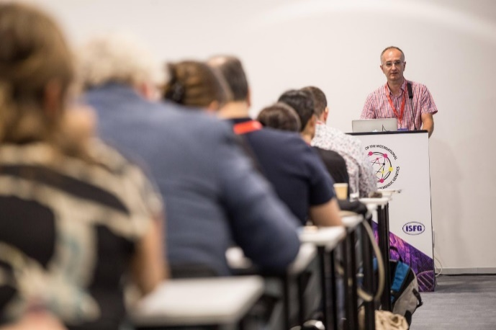
- Forensic DNA Phenotyping: Basics of Data Acquisition and Interpretation (Wojciech Branicki)
- Scientific Publication: Reading, Writing, and Reviewing (John Butler)
- Making Sense of Ethical, Legal & Social Aspects of Forensic Genetics (Matthias Wienroth & Gabrielle Samuel).
The Congress opened with a fluorescence mapping show illustrating the congress motto “Alchemy of Forensic Genetics” that brought a magical feeling, before the Czech scientists Václav Pačes and Tomáš Ruml and the Congress President Jiří Drábek greeted the attendees and ISFG president Walther Parson formally launched the meeting.
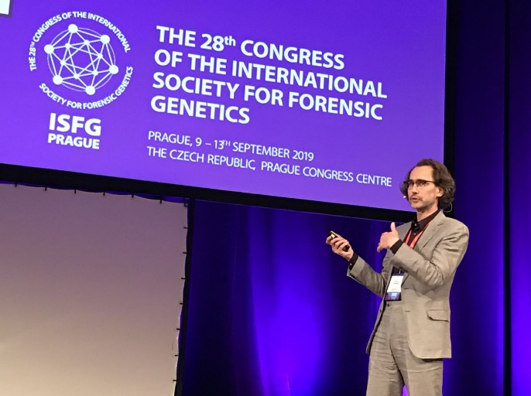
The program began with the ISFG scientific prize lecture given by Manfred Kayser entitled “Forensic appearance prediction from DNA: a journey through 10 years of scientific contributions.” In his presentation, Professor Kayser demonstrated both the power of sample numbers and the power of international cooperation as driving forces in growing the field of forensic DNA phenotyping.
Other invited plenary speakers included
- Lutz Roewer, who described complications and solutions in understanding and defining the term “population” by different stakeholders,
- Halina Šimková, who described differences in peoples´ perception of information and an approach to convey challenging concepts such as Bayes theorem using graphics of a water stream and lever,
- Yaniv Erlich, who presented both the power of familial searches in genealogical databases with the scale of millions of individuals and the risk of massive genetic surveillance along with practical suggestions to reconcile the two opposite societal values of genetic privacy and fighting criminals,
- Roland van Oorschot, who focused on expert opinion, training, and proficiency testing in DNA-related activity-level issues, involving DNA transfer, persistence, prevalence, and recovery,
- Fanny Pouyet, who elucidated the process of purifying selection when neutral diversity linked with deleterious variants is affected by by-stander effect, and
- Antonio Amorim, who described the large field of using non-human DNA in the court while highlighting the delay of non-human forensic genetics in terms of adopting standards, and QA/QC guidelines.
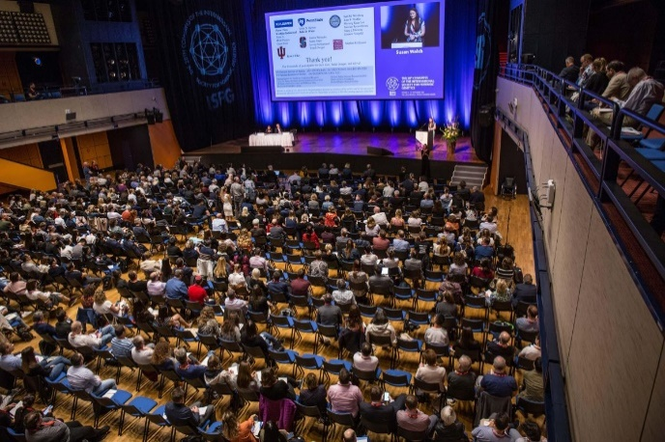
An additional 60 oral presentations and 601 posters satisfied any curious scholar looking for a forensic genetics crash-course or update on the latest research. The congress proceedings will be published in December 2019. For those who want to remember their days in Prague, selected photos from each day are still available online (https://www.isfg2019.org/photo-gallery.htm).

CONGRESS PRIZES
Scientific highlights of any conference may be subjective. However, this time popular vote (conducted via a conference software voting app) and the scientific committee vote all agreed on the two prize winners.
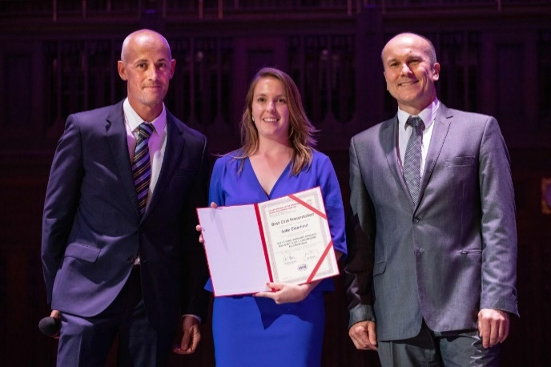
The best oral presentation prize was awarded to Sofie Claerhout (KU Leuven, Belgium) for her presentation: “CSY? a panel-based MPS approach including 12,523 Y-chromosome polymorphisms”.

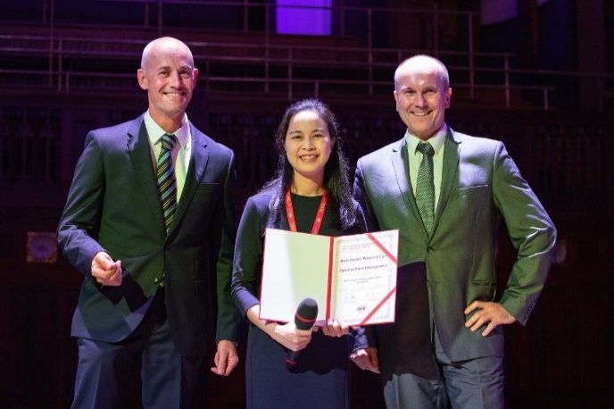
The "Best Poster" prize was awarded to Piyamas Kanokwongnuwut (Flinders University, Adelaide, Australia) for her poster: “Detection of cellular material within handprints”.

CONGRESS TRAVEL BURSARY
As before in Seoul, the ISFG was able to award travel stipends to a group of young forensic scientists who were ISFG members and had submitted abstracts to present at the meeting. On Thursday all travel award winners met with ISFG president Walther Parson, congress president Jiří Drábek and ISFG vice president Mechthild Prinz to receive their certificates.
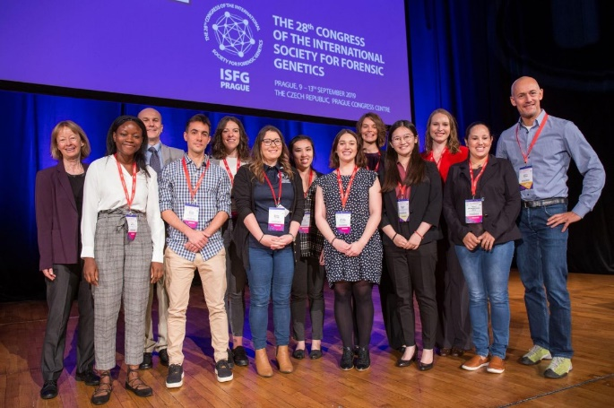

ISFG General Assembly
During the 28th ISFG Congress, the General Assembly elected John Butler (Gaithersburg, MD) as the new president of the society. Also, Leonor Gusmão (Rio de Janeiro, Brazil) was elected as new Representative of the Working Parties, and Marielle Vennemann (Münster, Germany) was elected as new Treasurer of the ISFG. Furthermore, the Assembly decided that Ate Kloosterman (Amsterdam) as well as Hermann Schmitter (Wiesbaden), two scientists who have been involved in the formation of the European DNA Profiling (EDNAP) Group 30 years ago in 1989, will become Honorary Members. After having served in the executive board for eight years as working group representative, president, and vice president Mechthild Prinz is leaving the board and expressed her gratitude to ISFG members for their support over the years. Former president Walther Parson is now the vice president.
The minutes of the General Assembly are attached to this newsletter (in English and German).

Scientific Prize Winners
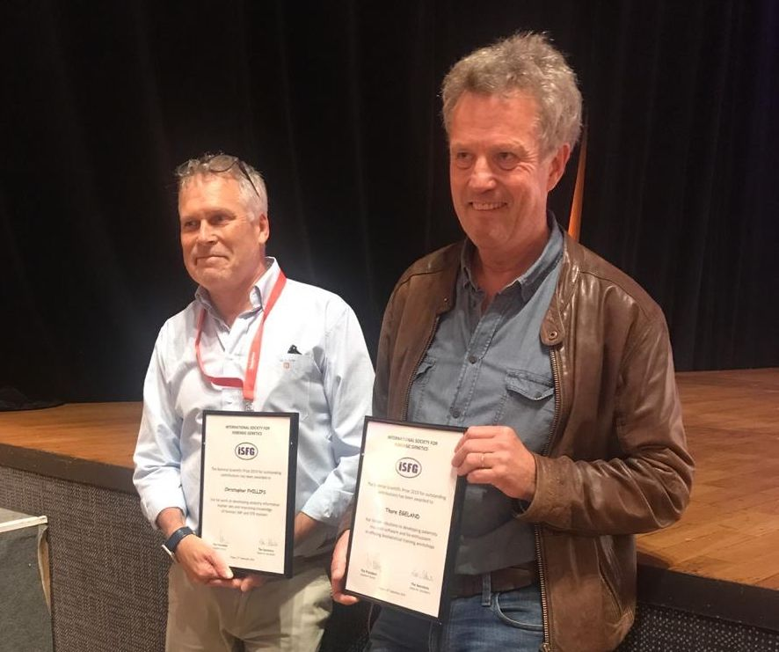
The 2019 scientific prize was awarded to two worthy recipients, Chris Phillips from the University of Santiago de Compostela, for his work on developing ancestry informative marker sets and improving knowledge of forensic SNP and STR markers, and Thore Egeland from the Norwegian University of Life Sciences in Oslo, for his contributions to developing paternity statistics software and his enthusiasm in offering biostatistical training workshops. Both recipients will be invited to present an overview of their work at the 2021 congress.
ISFG Congress 2021
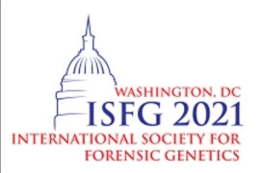
The 29th International Congress in Washington, D.C., will take place in the Marriott Marquis Hotel located only a few blocks from the city center. The congress will be held August 23rd to 29th, 2021. As always, the congress will cover the latest research and discuss legal and ethical concerns in forensic genetics. The pre-congress workshop schedule (August 23 and 24) is under development.
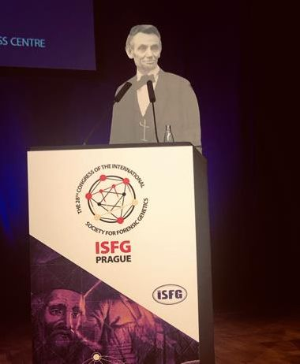
Abstract submission and early registration will open December 2020. The future ISFG 2021 congress president Christian Westring and vice president Heather McKiernan attended the meeting in Prague to listen and learn. Conference preparations are on track; please monitor the website http://www.isfg2021.org for information.

ISFG Congress 2023
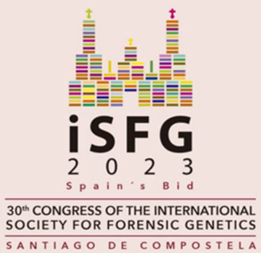
As venue for the 30th ISFG Congress in 2023, the city of Santiago de Compostela (Spain) was elected. The proposed dates are September 4th to 8th, 2023. On behalf of the local organizing committee, the bid was presented by Angel Carracedo from the Institute of Forensic Science of the University of Santiago de Compostela, and unanimously accepted by the ISFG General Assembly.

ISFG Congress 2025
The ISFG Executive Board invites expressions of interest to host the 31st ISFG Congress in 2025 in a non-European venue. Please send a one-page-text with details about the city, venue, and organizing committee to the ISFG Secretary.

ISFG Fellowship Report
ISFG Short-Term Fellowships support transnational exchange visits between collaborating research groups for scientists working on specific forensic genetics projects. Each fellowship provides financial support for travel and accommodation of up to 1000 euros for visits within the same continent and up to 2000 euros for visits across continents. Up to ten scientists are funded in each round following review by the ISFG Fellowship Review Board, which is composed of the chairpersons of the ISFG Working Parties and chaired by the Representative of the Working Parties in the ISFG Executive Board.
The 10 awardees for the most recent submission period (September 1 to October 15, 2019) are Vania Pereira (University of Copenhagen, Denmark), Torben Tvedebrink (Aalborg University, Denmark), Margherita Colucci (University of Leicester, UK), Kimberly Sturk-Andreaggi (Armed Forces DNA Identification Laboratory, USA), Byron Freire Paspuel (Universidad de Las Americas, Equador), Franco Marsico (Banco Nacional de Datos Geneticos, Argentina), Julyana da Silva Varela Ribeiro (State University of Rio de Janeiro, Brazil), Jorge Ruiz Ramirez (University of Santiago de Compostela, Spain), Masinda Nguidi (State University of Rio de Janeiro, Brazil), and Isabela Brunelli Ambrosio (Universidade Estadual Julio de Mesquita Filho, Brazil).

50th ISFG Anniversary Brochure
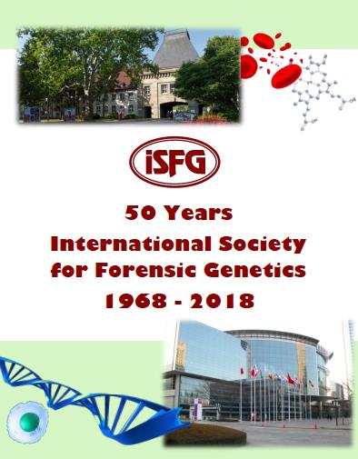
To celebrate the occasion of the 50th anniversary, the ISFG board issued a small brochure featuring the ISFG history, a working group overview, a chronology of prize winners and some personal memories of members from all over the world. The printed brochure was distributed at the congress, and can be downloaded as a pdf file from the ISFG website. A few paper copies are still available, so please contact Peter Schneider for a copy.

ISFG Summer School 2020
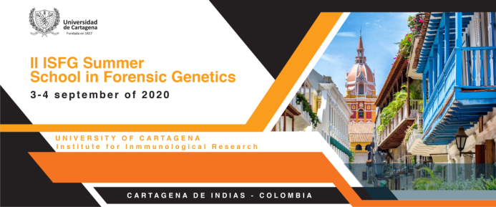
The Spanish and Portuguese speaking ISFG Working Group (GHEP-ISFG) will organize a summer school in Cartagena, Colombia, on September 3rd to 4th, 2020. The program is currently in preparation, and a detailed announcement with topics, speakers and registration details will be published in January 2020.

ESWG Meeting 2020
The next scientific meeting of the English Speaking Working Group will be held in Oslo, Norway, 2nd to 4th September, 2020. It will be held at the Department of Forensic Sciences, Oslo University Hospital. More information will soon be available.
Please go to https://farskap.no/no/eswg-20202/ for the latest information.

Haploid Markers 2020
The 12th Haploid Markers Meeting will take place May 13th to 16th, 2020 in Budapest, Hungary. The Conference motto is “Big data – stretching the borders of forensic genetics”. Novel sequencing techniques have significantly increased the body of haploid data and will continue to shape our understanding of extant lineage variation. This also impacts forensic applications. Therefore, attendees who specialize in this aspect are encouraged to submit relevant abstracts. All conference details can be retrieved from the meeting website http://www.hm2020.hu/

ISFG Executive Board: W. Parson, M. Prinz,
L. Gusmão, J.M. Butler, P.M. Schneider
(December 2019)

